„SAXONY!visit"
A business tour trough aviation and aerospace location Saxony

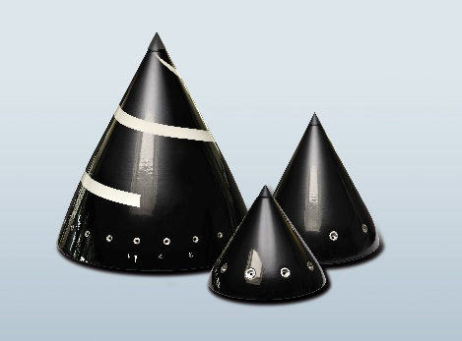
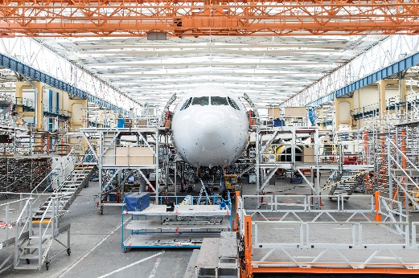
Programm Draft
18 – 20 · April · 2023
Dresden, Sachsen

Program - draft
(date March 14nth 2023, amendments possible)

Day 1 | April 18th 2023

Time | Topic
11:00 - 12.30h | Businesss visit: Diehl Aviation Gilching GmbH, Zum Windkanal 10, 01109 Dresden  Topic: Aviation
12:30 - 14:00h | Lunch and transfer to Networking Event
13:30-13:45 h | Parking at Hotel – Motel One, Am Palaisplatz, Dresden  Transfer from Hotel to Impact Hub
14:00 –  14:30 h | Registration and welcome coffee at Networking Event  at Impact Hub Dresden – Galerie , Trompeterstraße 5, 01069 Dresden
14:30 –  15.30 h | Networkingevent  - Official greeting, reception and welcome by  Wirtschaftsförderung Sachsen GmbH / Saxony Trade & Invest  Dr. Thomas Richter, Vice Precident Saxony Trade & Invest  - Business Location Saxony –  Competence Center Aerospace and space Technology Saxony / Thuringia e.V. - LRT Sachsen, Branch cluster  - Impulse presentation Poland Space Technology  - Impulse presentation Poland Aerospace Industry  - Introduction round - Guest Poland (3-5 sentences, max 1 minute)  - Project topics and procedure – Anna Kurzynoga & Frederico Rosenbaum, Project Manager’s at Saxony Trade & Invest
15:25 | Networkingevent – short coffee Break
15:30h  17:30 | Networkingevent – B2B Meetings  B2“ Meetings and networking --self arranged, supported by an event app. Further Saxon companies will be invited!
17:30-  18:30 | Networking – open session and networking with small dinner buffet
18:30 | Transfer to the Hotel
18:30 -19:30 | Optional: guided City tour Dresden (at least 10 participants)
18:45 | Check inn at the Hotel  Hotel: Motel One am Palais Platz 1, Dresden  https://www.motel-one.com/de/hotels/dresden/hotel-dresden-palaisplatz

Day 2 | April 19th 2023

Time | Topic
07:00 | Breaktfast at the hotel
07:45 | Transfer for Business visit Tour 1  (Topic: Space) | Transfer for Business visit Tour 2  (Topic Aviation / Leigthweigth)
08:30 - 10:00 | Business visit: BEYOND GRAVITY GmbH  An d. Walze 7, 01640 Coswig  max. 15 attendee’s ! | Company Presentation: Herone GmbH  Meschwitzstraße 21, D - 01099 Dresden
10: | Transfer
11.00-  12:30 | Company Presentation: Morpheus Space | Business visit: Technische Universität Dresden, Institut für Leichtbau und Kunststofftechnik (Institute of Lightweight Engineering and Polymer Technology) – Dr. Albert Langkamp
12:30 | Lunch | Lunch
 | Transfer | Transfer
13:30 - 15:30 | Business visit: PMG Precision Mechanics Group GmbH, Hühndorfer Höhe 21, 01723 Wilsdruff  Topic: Aviation
15:30 - | Transfer
16:00 - 18:00 | Business visit idea: EFW Elbeflugzeugwerke – Dr. Gärtner  Topic: Aviation / Leightweight
19:00 - 21:00 | Transfer to Poland - GROUP from Lower Silesia  Dinner (tbd), after that Free Time - GROUP AHK Poland

Project coordination in SAXONY
Wirtschaftsförderung Sachsen GmbH/ Saxony Trade & Invest
Frederico Rosenbaum / Anna Kurzynoga
frederico.rosenbaum@wfs.saxony.de
anna.kurzynoga@wfs.saxony.de
www.business-saxony.com

Project funding
This project is funded by the Saxon State Ministry for Economic Affairs, Labor and Transport (SMWA) and coordinated by the Saxony Trade & Invest (www.business-saxony.com). Kompetenzzentrum Luft- und Raumfahrttechnik Sachsen/Thüringen (LRT e.V.) is mandated to support at the project. AHK Polen is mandated to support at the project in Poland.

Sources: Left picture = EAST4D, right picture =EFW Elbeflugzeugwerke

